

UTTAR PRADESH STATE INDUSTRIAL DEVELOPMENT CORPORATION LIMITED

BUILDING PLAN APPROVAL



**TENDER CREATION &** **PUBLISHIN**

1. Step 1 To Login into the system Open Internet or chrome browser -> type <http://eservices.onlineupsidc.com/> in the address box



**Figure 1. Opening ERP Portal**

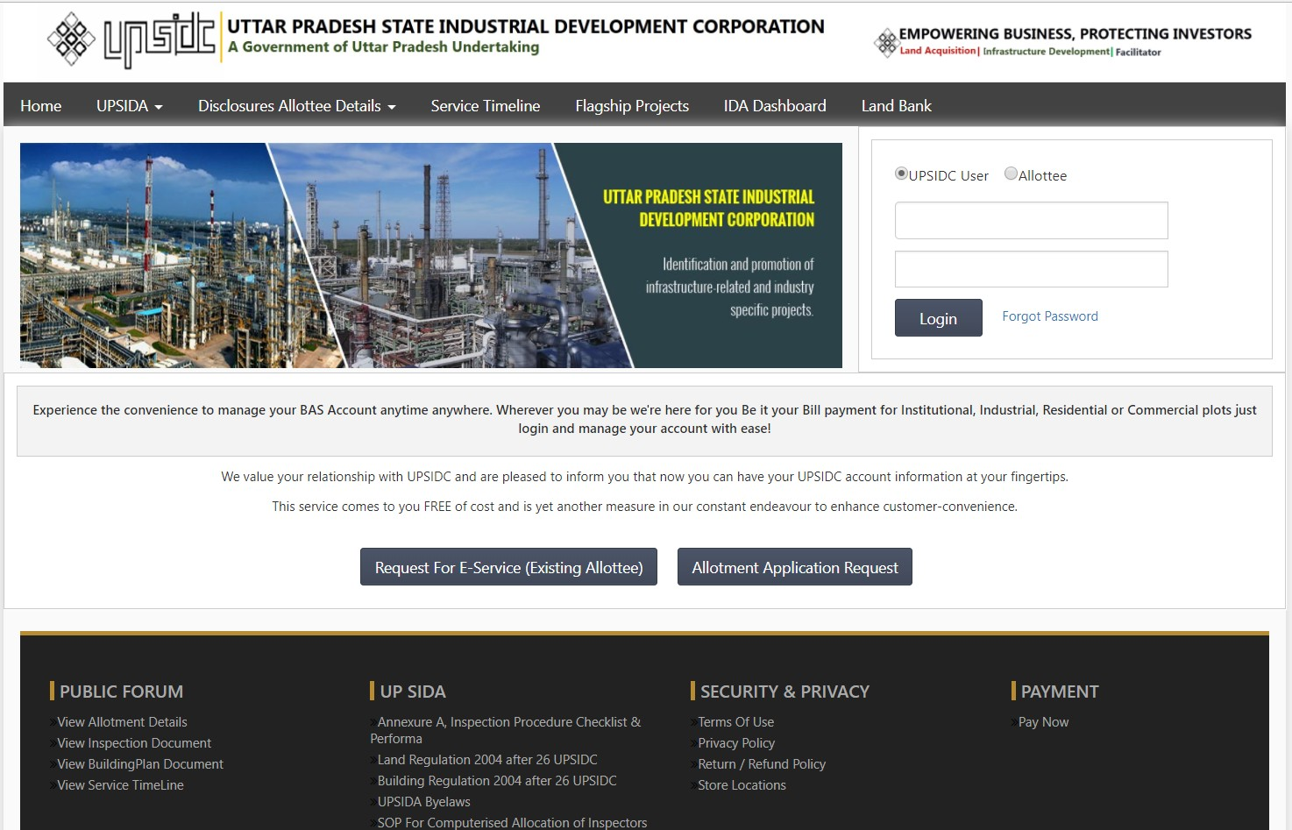

1. Login with username & password
2. Click on Raise service request

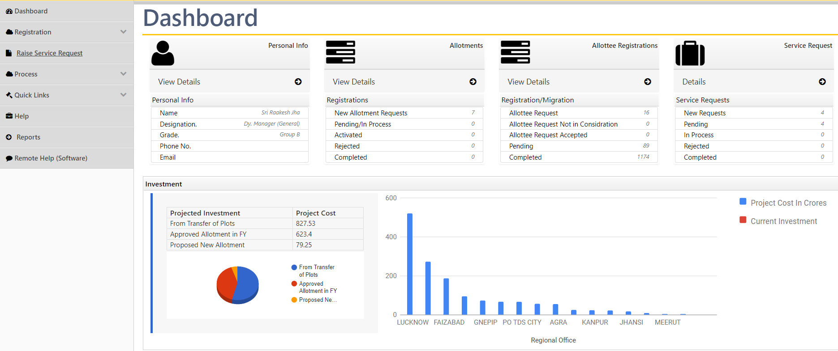

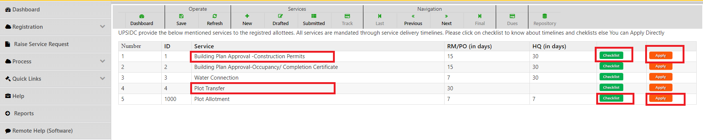

3. Click on Checklist

**Checklist: - View required document**

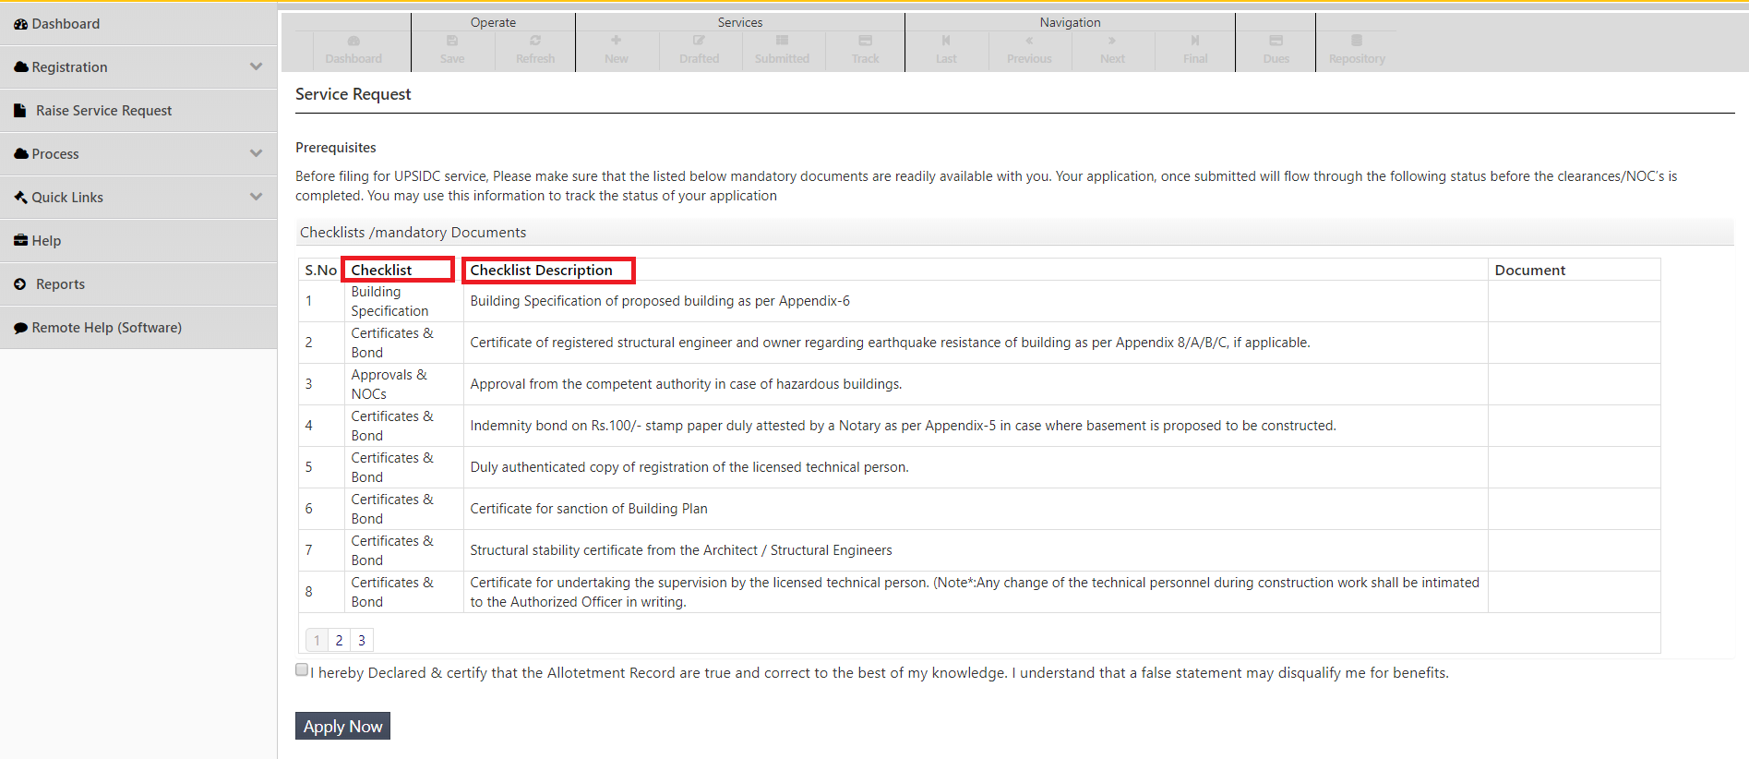

4. View Required Document

**Click on Apply Button**

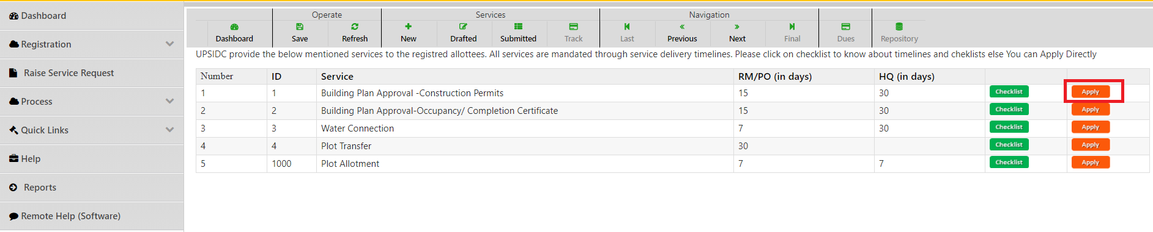

5. Click

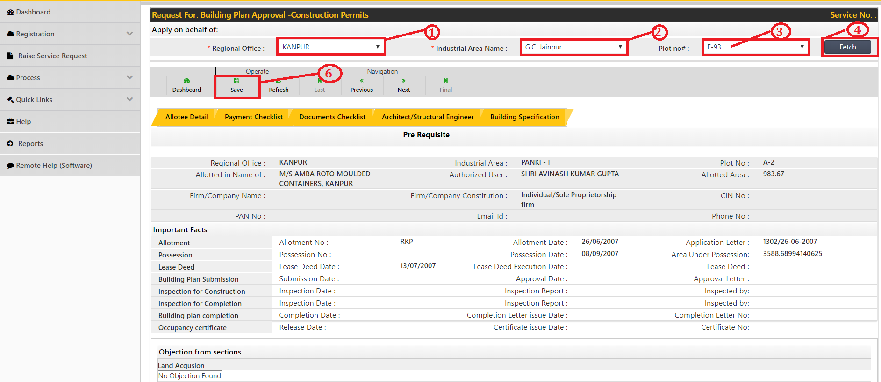



1. Select regional office
2. Select Industrial Area Name
3. Select plot no.
4. Click on fetch button
5. Select service request case type
6. Click on save button

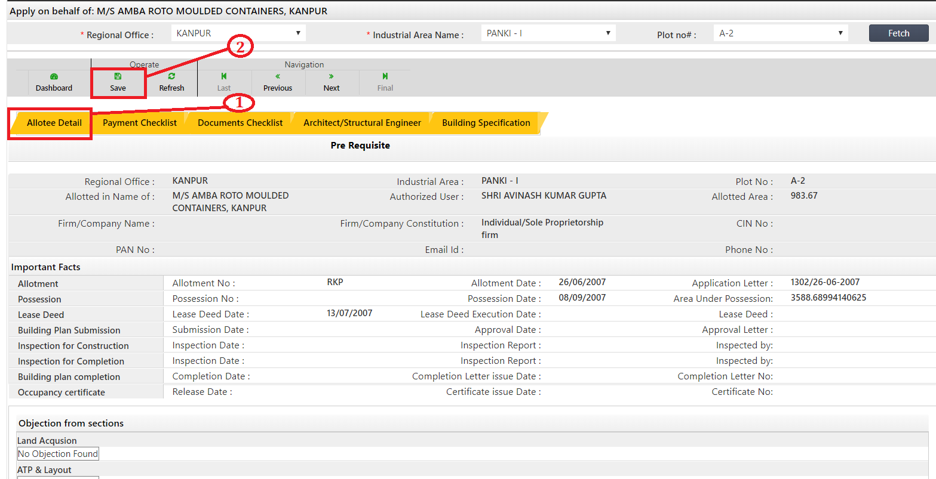

1. Click on Allotee Detail and view and verify allotee Detail correct or not
2. Click on save

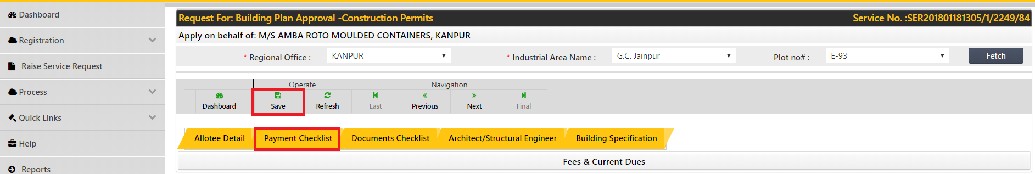

1. Click on payment checklist for payment detail
2. Click on save

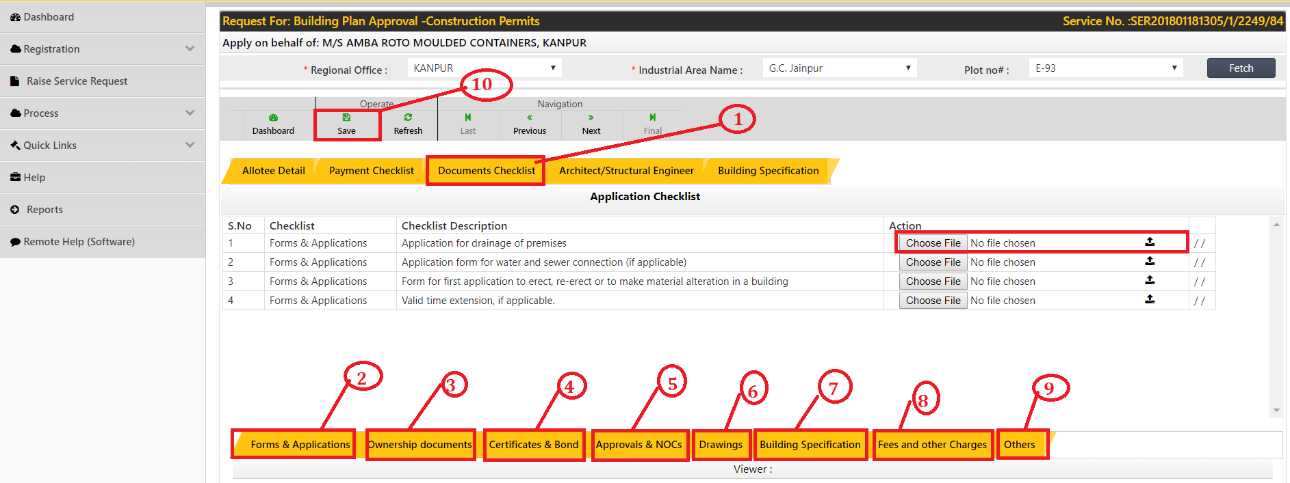

1. Click on documents checklist
2. Upload form application document
3. Click on ownership documents button to upload respective document
4. Click on certificate & bond button to upload respective document
5. Click on approvals and NOCs button to upload respective document
6. Click on drawings button to upload respective document
7. Click on building specification button to upload respective document
8. Click on fees and other charges button to upload respective document
9. Click on other to upload respective document
10. Click on save button

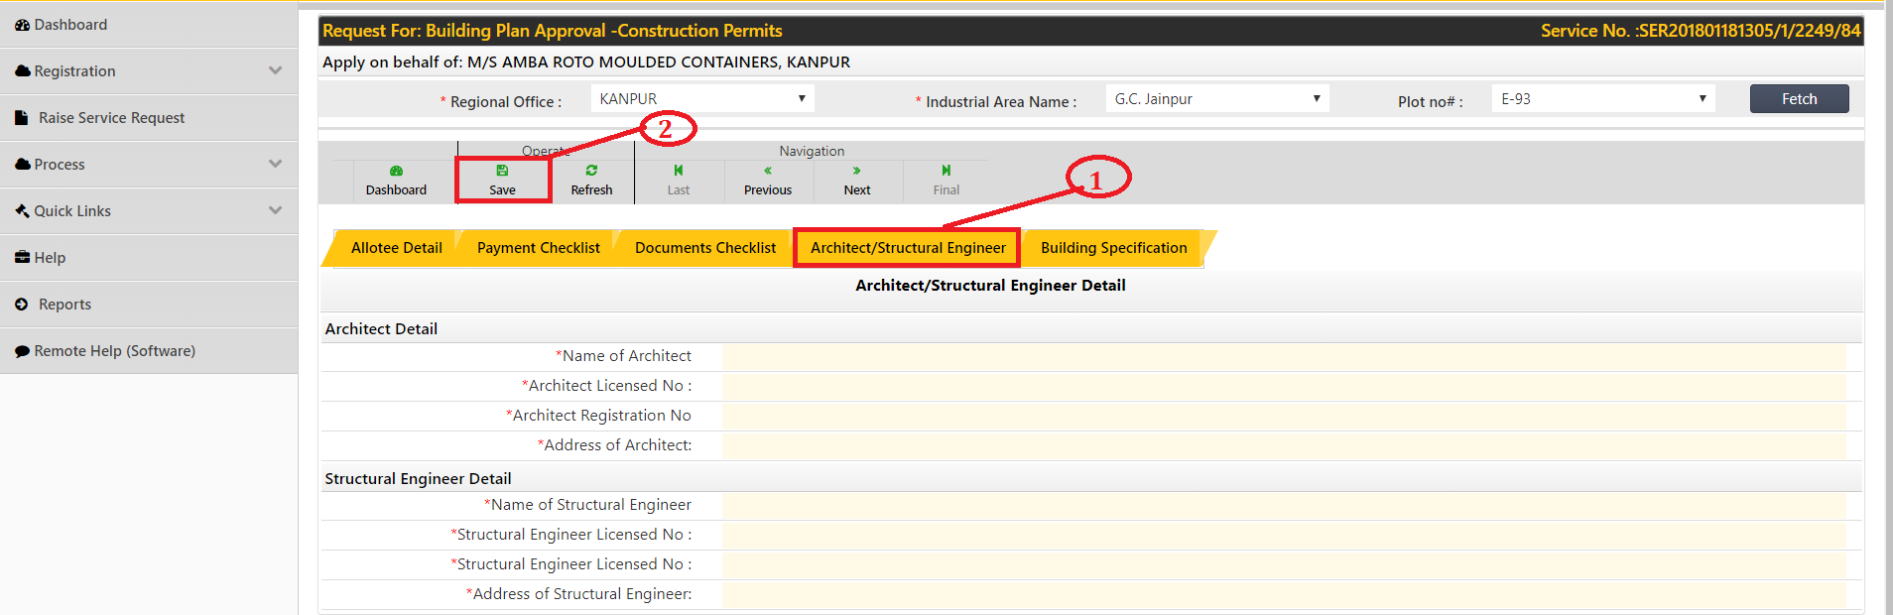

1. Fill Architect/ structural detail
2. Click on save

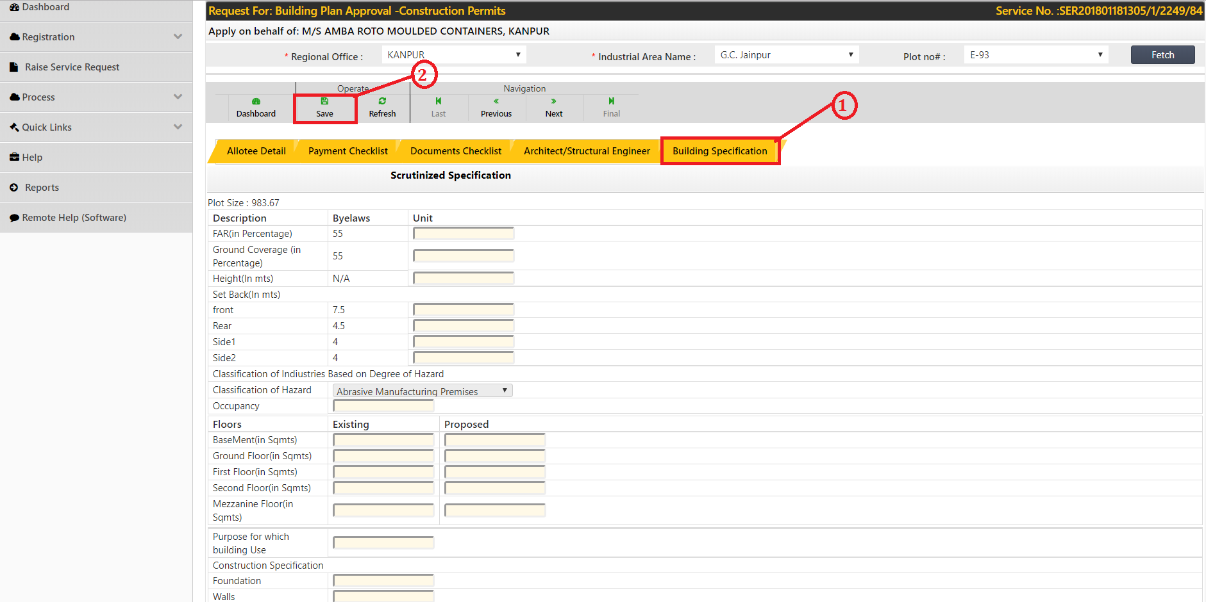

1. Fill building specification details
2. save